Hunter Smith, Taniyah Epps, Jayden Scott

Software Design and Development

4/11/2025

Implementation Details (Deliverable 4)

This document illustrates the software's functionality through relevant snapshots. Here is the current progress of our website which includes some front-end, back-end, and database screenshots.

**Front-End Display**

**Index.html (Home)**

This page functions as our home screen where some available events will be shown to the user. Eventually, the user will be able to search and filter the events.

**Events.html**

This page will function as the page to add events and delete them.

**Login.html**

A simple login for our users.

**Signup.html**

Create Account page for our new users.

**Profile.html**

This page will display information on the logged in user including tickets they have purchased or events they have saved. Currently we are adding the ability for a user to “purchase” a ticket. Those purchased tickets will be displayed here!

**Back-End Code**

**App.py**

This handles the main code to run the server and establish our database models. It also handles establishing the routes (http requests) for the website so that the pages may be accessed.

**Seed_data.py**

This is our current manual injection of information into SQLite. It is not the long-term solution but is current so that DB info is being displayed on the site.

**App.js**

App.js handles fetching and displaying events from our DB onto our website

**Database**

Here is our SQLite Database Currently. We are planning on migrating to MySQL or a different database as our initial experience has not been great. We have injected examples, events, and a user which is all stored in a DB file within the project.

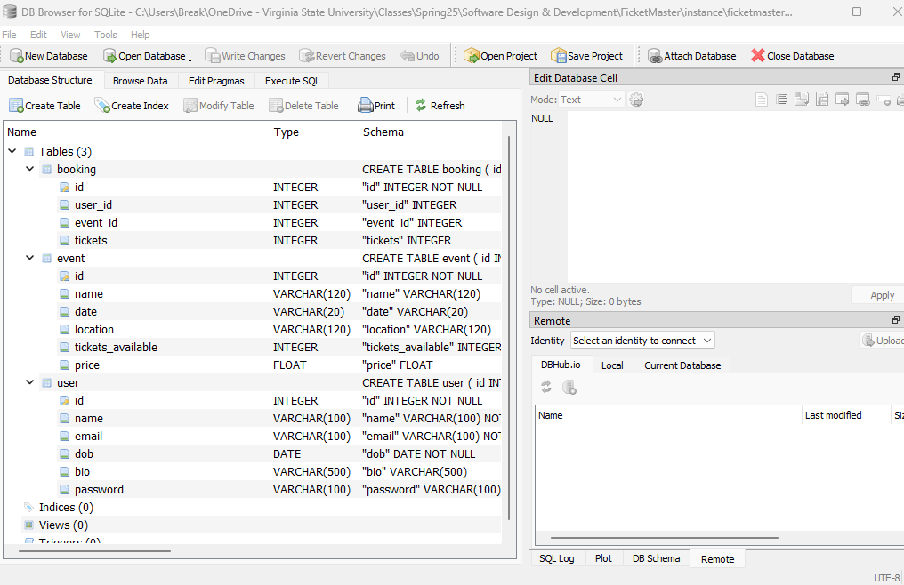

**Goals of Project:**

The current website is a prototype. While full database integration and on-site payment functionality would require a larger-scale development timeline, we are continuing to work on making booking features available—even if only in a simulated or non-functional state for now. Additionally, we plan to improve the website’s CSS to create a more welcoming and user-friendly experience.